上 海 跨 境 电 子 商 务 行 业 协 会 简 介

上海跨境电子商务行业协会（Shanghai Cross-Border E-Commerce Association）（以下简称协会）成立于2014年1月20日，注册地为中国上海。是国内第一家跨境电商行业协会，协会的业务主管部门是上海市商务委员会，同时接受上海市社会团体管理局的监督和指导。
协会目前拥有近200家会员单位，主要来自跨境平台、电商平台、国际贸易、跨境物流、跨境金融、第三方服务等六大类，涵盖跨境电商产业链条的各个环节。在国内及上海市有跨境电商业务的代表性企业，基本都是本协会会员。
协会首任会长单位是东方航空物流有限公司，现任会长为东方航空物流有限公司总经理李九鹏先生，秘书长夏世锋女士。
协会的宗旨是遵守国家宪法、法律、国家及地方法规和社会道德风尚，贯彻执行党和国家、地方的方针政策，围绕上海“四个中心”建设的目标，做好政府和企业沟通的桥梁；运用交流、调研、咨询、协调、培训、评比等多种形式为行业和会员提供服务，协助政府进行行业管理，维护市场秩序，维护会员合法权益，推动行业繁荣和发展。
协会在政府授权的范围内开展活动，具体包括：标准制定、咨询服务、行业调研、数据统计、会展活动、人才培训、合作交流、行业自律和承接政府委托的事项等。
协会热忱欢迎全球各地从事跨境电子商务的企业、民间组织、科研机构及其他经济组织加入，共同为推动全球贸易便利化和世界各国人民的福祉作出积极贡献。

更多详细信息请关注协会网站 www.scea.co
微信公众号：scea2014。
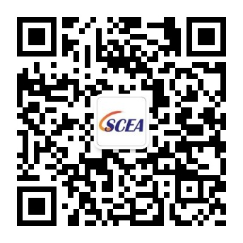

Brief Introduction of Shanghai Cross-Border E-Commerce Association

Shanghai Cross-Border E-Commerce Association, hereinafter referred to as SCEA, was approved to be established on January 20th, 2014. SCEA runs its operations under the supervision of Shanghai Municipal Commission of Commerce and under the guidance of Shanghai Civil Affairs Bureau.

Currently, SCEA consists of nearly 200 registered member enterprises, which could be mainly divided into 6 categories, i.e. logistical and express enterprises, financial and payment enterprises, E-commerce enterprises, E-platform enterprises, international trade enterprises, and third-party services providers. Most representative enterprises involved in Shanghai Cross-Border E-commerce business have become SCEA member enterprises.

As per democratic election results issued by successive meetings of first-term board of directors, first-term Chairman Enterprise of SCEA is Eastern Airlines Logistics Co., Ltd., with its president Mr. Li Jiupeng as the Chairman. Secretary General is Ms. Xia Shifeng. In addition, there are 16 Vice-Chairman Enterprise, 2 Standing Director Enterprise and 38 Director Enterprises.

As per the Constitution, relevant governmental and local laws and regulations, SCEA aims at serve as the communication bridge between the government and the enterprises via implementing governmental and local guidelines and principles as well as the objective of Shanghai 4-Centers construction. Provide services for the industry of cross-border E-commerce as well as the member enterprises involved by means of communication, investigation, consultation, coordination, etc., assist the government in managing the industry, maintaining market order, ensure legitimate rights of member enterprises, and prompt the prosperity of the industry.

The operation scope of SCEA can be concluded as follow: standards formulation, consultation service, industry investigation, data statistics, conferences and exhibitions, personnel training, cooperation and communication, industry self-discipline and other affairs contracted by the government.

All sorts of enterprises, institutions, and non-profit organizations that are involved in the industry of cross-border E-commerce, are more than welcomed to join SCEA, to contribute to the facilitation of global trade and the merits of citizens worldwide.

For more detailed information, please visit our official website, www.scea.co,
or follow us via Wechat subscription number, SCEA2014.

