**上海跨境电子商务行业协会简介**

上海跨境电子商务行业协会（Shanghai Cross-Border E-Commerce Association）（以下简称协会）成立于2014年1月20日，是得到上海市商务委员会作为业务主管单位批复，在上海市社会团体管理局依法登记的国内首家跨境电商行业协会。

上海东航快递有限公司担任新一届会长单位。现任会长、上海东航快递有限公司执行董事王建民先生，秘书长夏世锋女士，始终不渝地关心和引领行业的持续发展。

在政府的悉心关怀下，协会有近400家会员单位，吸纳国内外有代表性的跨境电商企业，服务上海及周边地区上千家跨境电商企业，涉及跨境电商平台、贸易、物流、金融支付等跨境电商产业链中每个环节。

协会下设专家智库和包括跨境电商平台、外贸、跨境物流与供应链、跨境金融、海外仓、数字经济、海外进口品牌服务、化妆品、生鲜冷链、教育机构、先锋企业在内的十大专委会，成立“长三角跨境电商联盟”、“上海跨境电商产学研联盟”、“一带一路”跨境电商经贸联盟，为企业提供精准、专业的服务。

协会在上海市商务委员会、上海海关、国家税务总局上海市税务局、国家外汇管理局上海市分局等跨境电商政府部门的指导和支持下，开展政策动态解读、专业技能培训、进博效应承接、商务资源整合、校企人才合作、短期海外研修、行业报告编写等各项工作，多次被上海市商务委员会授予感谢信。

协会先后被市政府和社会组织评为“中国国际进口博览会上海交易团跨境进口电商联盟”理事长、“中国（上海）自由贸易试验区优秀合作伙伴”、“上海投资促进机构卓越联席会员”、“上海现代服务业联合会突出贡献奖”和“长三角优秀社会组织”荣誉称号，与百余国家的使领馆和商协会缔结友好合作，不断加强资源对接，持续推动上海经贸发展。

鹤鸣九皋，声闻于天。协会博采众长、凝心聚力、务实创新、乘风破浪，为上海跨境电子商务事业开创更美好的未来。

更多详细信息请关注协会网站[**www.scea.co**](http://www.scea.co)

微信公众号/协会抖音：**scea2014**

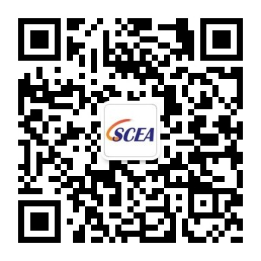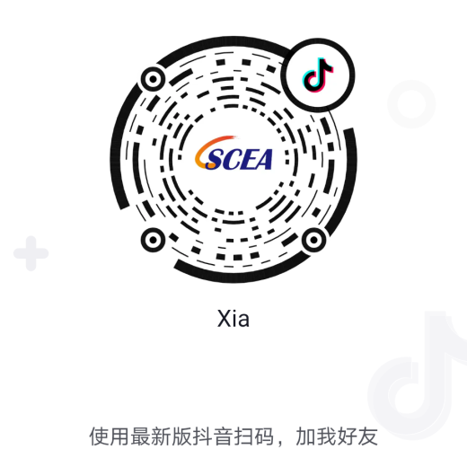

协会公众号 协会抖音

**Brief Introduction of Shanghai Cross-Border E-Commerce Association**

Shanghai Cross-Border E-Commerce Association, hereinafter referred to as SCEA, was approved to be established on January 20th, 2014. SCEA is the first domestic Cross-Border E-Commerce Association, approved by Shanghai Municipal Commission of Commerce as the business competent unit and registered in Shanghai Municipal Administration of social organizations according to law.

Shanghai Eastern Airlines Express Co., Ltd. as the new chairman of the unit. Mr. Wang Jianmin, president and Executive Director of Shanghai Eastern Express Co., LTD, and Ms. Xia Shifeng, the secretary general, always care about and lead the sustainable development of the industry.

Under the careful care of the government, SCEA has nearly 400 member units, absorbs representative cross-border e-commerce enterprises at home and abroad, and serves thousands of cross-border e-commerce enterprises in Shanghai and surrounding areas, involving every link of the cross-border e-commerce industry chain such as cross-border e-commerce platform, trade, logistics and financial payment.

SCEA has established expert think tanks and ten special committees, including cross-border e-commerce platforms, foreign trade, cross-border logistics and supply chain, cross-border finance, overseas warehouse, digital economy, overseas imported brand services, cosmetics, fresh and cold chain, educational institutions and pioneer enterprises, and established " Changjiang delta cross-border e-commerce alliance" and "Shanghai cross-border e-commerce industry university research alliance" "One belt, one road" cross-border electricity supplier economic and trade alliance provides precise and professional services for enterprises.

Under the guidance and support of the Shanghai Municipal Commission of Commerce, Shanghai Customs, the State Administration of Taxation, Shanghai Municipal Bureau of Taxation, the Shanghai Branch of the State Administration of foreign exchange and other cross-border e-commerce government departments, SCEA has carried out various work, such as policy dynamic interpretation, professional skill training, undertaking of Expo effect, business resource integration, school enterprise talent cooperation, short-term overseas research and preparation of industry reports, It has been awarded many thank-you letters by Shanghai Municipal Commission of Commerce.

SCEA has been successively awarded the honorary titles of "China International Import Expo Shanghai trade group cross border import e-commerce alliance", "excellent partner of China (Shanghai) pilot free trade zone", "excellent joint member of Shanghai Investment Promotion Agency", "outstanding contribution award of Shanghai Modern Service Industry Federation" and "excellent social organization in the Yangtze River Delta" by the municipal government and social organizations, It has concluded friendly cooperation with embassies and consulates and business associations of more than 100 countries, continuously strengthened the docking of resources, and continued to promote the economic and trade development of Shanghai.

For more detailed information, please visit our official website, [**www.scea.co**](http://www.scea.co/)**,**

or follow us via Wechat Subscription/Tik Tok number,  SCEA2014.

 

Wechat Subscription Tik Tok